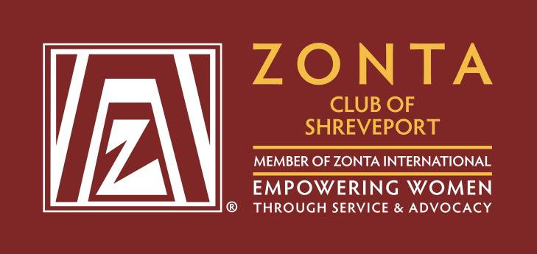
2025 Zonta Zoom Halloween 5K
Sponsor Form

Platinum Level $1000
- Full enlarged logo on back of race shirt
- Recognition on social media
- 6 tickets for race and 6 race shirts
- Option to include promotional materials in race bags
Gold Level $500
- Full logo on back of race shirt
- Recognition on social media
- 4 tickets for race and 4 race shirts
- Option to include promotional materials in race bags
Silver Level $250
- Logo on back of race shirt
- Recognition on social media
- Option to include promotional materials in race bag
- 2 tickets for race and 2 race shirts
Bronze Level $100
- Company name on back of shirt
- Recognition on social media
- Option to include promotional materials in race bags
Saturday, October 25, 2025 Hamel Park
Please indicate sponsorship level of your commitment and submit payment through PayPal to ZontaShreveport5k@gmail.com or mail payment with form to Zonta Club of Shreveport, P.O. Box 38765, Shreveport, LA 71133

Company Name: ______________________________________
Address: ____________________________________________
City: ___________________ State: _______ Zip: ________
Contact Name: ________________Phone Number: __________
Email Address: _______________________________________
T-Shirt Sizes & Amount: ________________________________

Deadline for sponsorship is October 10, 2025 Logos/Emblems must be emailed to Zonta Shreveport (ZontaShreveport5k@gmail.com) for inclusion in social media and on t-shirts. Promotional materials must be received by Zonta Shreveport no later than October 20, 2025 for inclusion in race bags. *All money raised goes towards providing scholarships for local young women and local service projects.

